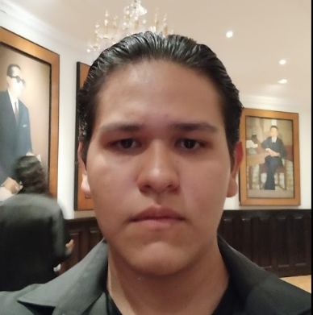Andres Ravelero Romo

Ocampo Sur 96, Tlajomulco de Zúñiga. Jal

Phone: 3319043810

Email: [Raveleroromoa@gmail.com](mailto:Raveleroromoa@gmail.com)

**Education**

* **Bachillerato General por Competencias, Escuela Preparatoria Regional de Tlajomulco de Zúñiga**, Universidad de Guadalajara
  + Duration: 2019B - 2022A
  + GPA: 95.64/100
  + Total Credits: 239

**Certifications**

* **Robotics: Entering the Age of Automation Course**
  + Duration: June 17, 2023 - August 12, 2023
  + Total Hours: 40
* **PC Proulex Certificate of English**
  + Date: February 10, 2022
  + Location: Tlajomulco de Zúñiga, Jalisco
  + Total Hours: 170
* **PDU Proulex University English Diploma**
  + Date: February 10, 2022
  + Location: Tlajomulco de Zúñiga, Jalisco
  + Total Hours: 480
* **Proulex Assessment English Proficiency Certificate**
  + Level: B1 of the CERF
  + Date: March 2022
  + Location: Guadalajara
* **TOEFL Prep Workshop Participation Certificate**
  + Organization: U.S. Department of State, English Language Programs
  + Instructor: Virtual English Language Fellow Matthew Handy
  + Location: Esquina Franklin, Guadalajara, Mexico
  + Date: March 31, 2023

**Achievements and Awards**

* **2nd Internal Spelling and Grammar Contest, First Phase Participant**
  + Date: March 25, 2022
  + Location: Escuela Preparatoria Regional de Tlajomulco de Zúñiga
* **Literary Creators Contest, Fiel Joven 2021 - Poetry Category Participant**
* **Drawing Contributor, "Space Continumm"**
  + Publication: Revista Biden No. 21
  + Organization: Sistema de Educación Media Superior, Universidad de Guadalajara
  + Period: July - November 2021
* **Rapid Reading and Pre-reading Course**
  + Organization: Hiper Lector
  + Date: September 25, 2019
  + Location: Guadalajara, Jalisco
  + Reading Speed: 761 words/minute
  + Comprehension: 80%
* **2nd Place - Teardown Map Contest Spring 2021**
  + Game: Teardown by Tuxedo Labs, a tech-driven game studio based in Malmö, Sweden.
  + Collaboration: Partnered with Ralf Brandenstein (username: @micro), a German co-creator.
  + Creation: "The Spring Isles" [**View on Steam**](https://steamcommunity.com/sharedfiles/filedetails/?id=2486499382)
  + Note: Securing the second place was a testament to my proficiency in Lua programming and the importance of English as a medium of communication, as collaborating with a German partner would have been unfeasible without it.
  + Date: 22/06/2021

**References** Available upon request.